Pendulum, Conservation of Mechanical Energy
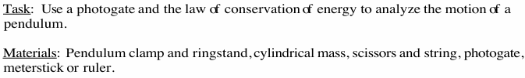
Part 1. Physics Laws and Mathematics Presentations:

1. Key Concepts:
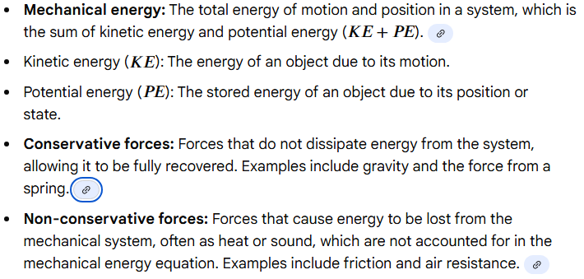

2. How can the mechanical energy be conserved?
If there are no non-conservative forces doing work on an object, its mechanical energy is conserved.

3. What is the conservation of mechanical energy?

4. What is the mathematical presentation of conservation of mechanical energy?
